multichain-util create Linus_Chain

First lets start the chain   
multchaind Linus_Chain  
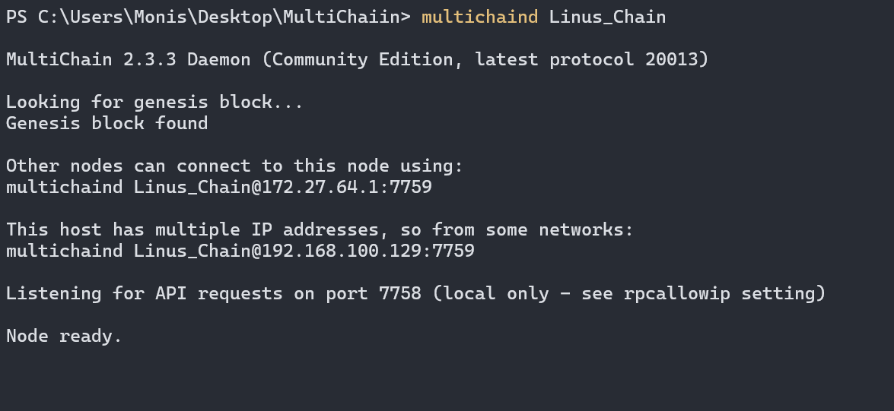

multichain-cli Linus_Chain listwallettransactions

Here we have the following attributes:  
txid: "0b33ff161cd0756992245abe73e36b194971cc17638e235599a78f63da92cf56”  
amount: 0 (No amount was set)  
confirmations: 6 (This would increase/decrease based on the transactions/assets)  
blockhash: "00e51b194e075f91fdffdbd8c9db054ede1ab23c98379b37b55eca410d8e1830"  
timereceived: 1741621800 (In seconds from epoch)

multichain-cli Linus_Chain getpeerinfo

Lets create an Asset on Linus Chain with the name Drop_Tips  
  
First get the address of the wallet

Multichain-cli Linus_Chain getaddress

Copy the address to the new command

~~multichain-cli Linus_Chain createasset Drop_Tips 1000 0.01~~ //This command throws an error so we use another command

multichain-cli Linus_Chain issue 1Kx8SRWHK4mqsVLVqoTVzGrqHoD82KcDvQYFPG "Drop_Tips" 1000 0.01  
//The address is for the chain



multichain-cli Linus_Chain listassets

Now we fetch some raw transactions

multichain-cli Linus_Chain getrawtransaction 0b33ff161cd0756992245abe73e36b194971cc17638e235599a78f63da92cf56 1

Lets generate a new address

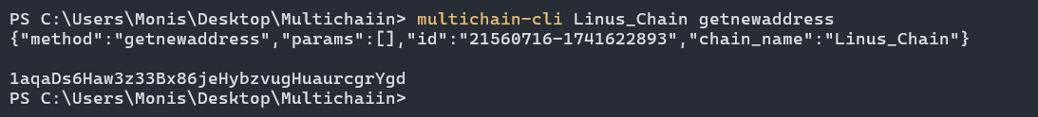

Comparing it with the old address

Since its stack based the new address is at the top.  
  
Now displaying miners In multichain

Since the node is created in our local machine, we are also the miner.

Bonus task :  
Burn an asset:  
We already created an asset called Drop_Tips to burn this address and to see how it handles lets create a new asset called “Jake”.

  
Asset created with 3000 amount.

Two assets on the same wallet.

Now lets burn the Drop_Tips assets to zero

First we would see the remaining balances as a baseline

Next we need the burn address

Burn address: "1XXXXXXXbiXXXXXXmXXXXXXXY9XXXXXXVyUwS7"

Before burning we must grant the address permission otherwise it would throw an error:



multichain-cli Linus_Coin grant 1XXXXXXXbiXXXXXXmXXXXXXXY9XXXXXXVyUwS7 receive

Now we can burn an asset.

Select an asset

We choose Drop_Tips and select a quantity to be burned if all the quantity is burned the asset is removed.



Asset burned

Now only one left

Now lets try with some amount on the Asset “Jake”

Another Bonus:  
What if we try to burn more than the available amount well!

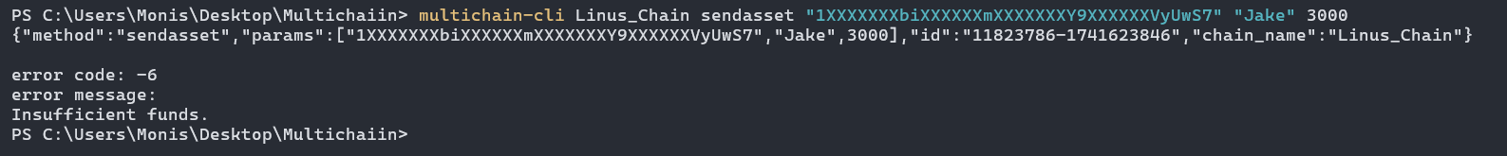

Insufficient Funds (Its not overdraft like conventional Banks)